
Accommodations
Explore the Outdoors

About Us
Activities
Dining & More
Home
MOFFAT BAY LODGE

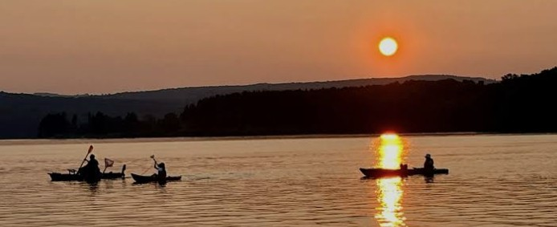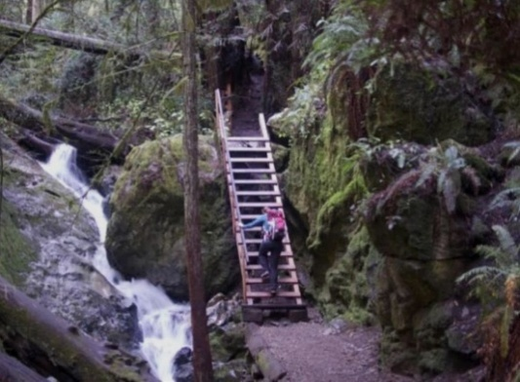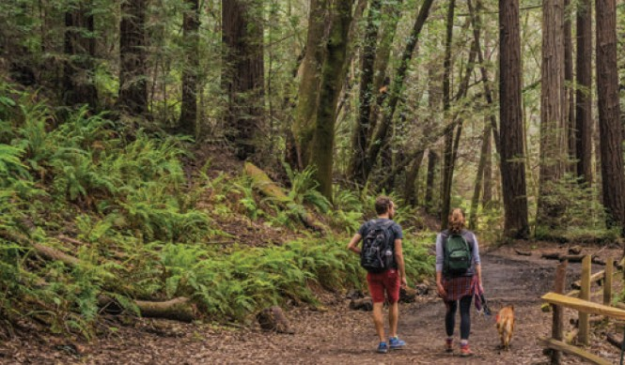
Adventurous Hiking Trails
- Trails for all skill levels.
- Guided nature hikes.
- Maps and trail info available at the lodge.
Kayaking & Canoeing
- Paddle across the bay
- Rentals available
- Peaceful morning excursions
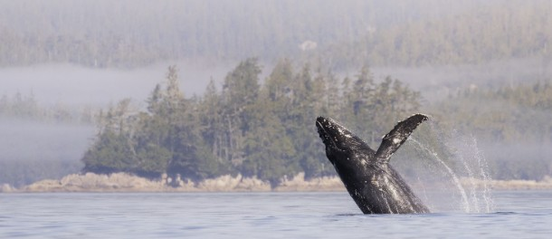
Whale Watching
- Guided excursions available
- Scenic coastal wildlife viewing
- Seasonal marine life experiences
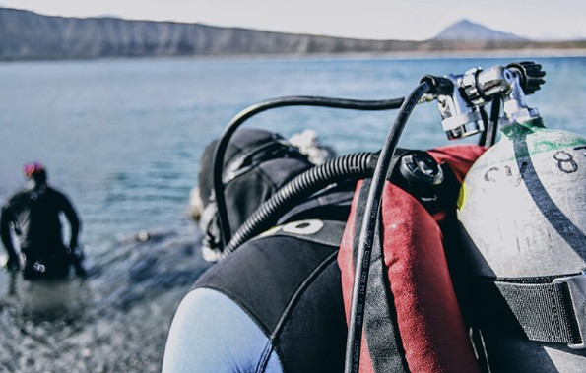
Ready to Explore?
Scuba Diving
- Explore underwater environments
- Guided dive options
- Equipment and safety guidance available
Register Here

